|  |  |
| --- | --- |
|  | **PES UNIVERSITY**  **(Established under Karnataka Act No. 16 of 2013)**  **100 Ft. Road, BSK III Stage, Bengaluru – 560 085**  **DEPARTMENT OF COMPUTER SCIENCE AND ENGINEERING** |

|  |  |  |
| --- | --- | --- |
| **Course Title: Problem Solving with C Laboratory** | | |
| **Course code: UE19CS152** | | |
| **Semester : II sem** | **Section:B** | **Team Id:** |
| **SRN: PES2UG19CS126** | **Name: Yochna Sheetal Garuda** | |
| **SRN: PES2UG19ME010** | **Name: DEBASHMITA PAL** | |
| **SRN: PES2UG19EC027** | **Name: CHINMAYI P SHETTY** | |
| **SRN: PES2UG19CS170** | **Name: K KEERTHANA** | |

**PROJECT REPORT**

**Problem Statement:**

**Periodic table**

**Description:**

**With the help of c programming we are able to implement modern periodic table in which we can add new elements, search for elements based on their name , symbol ,atomic mass ,atomic weight and also display element in each block**

**C-concepts used:**

**\*stdio.h,**

**\*conio.h**

**\*string.h**

**\*stdlib.h**

**\*Functions**

**\*Structures**

**\*File handling**

**\*Pointers**

**Learning Outcome:**

**We leant abut file management and different apptication of function,structures and pointers**

**Output Screenshots:**

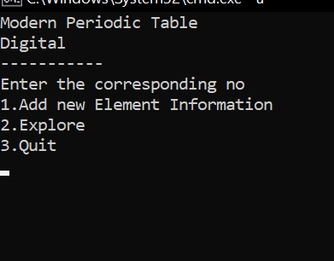 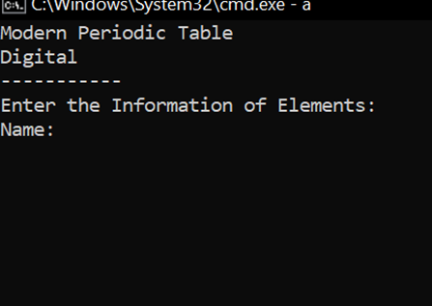

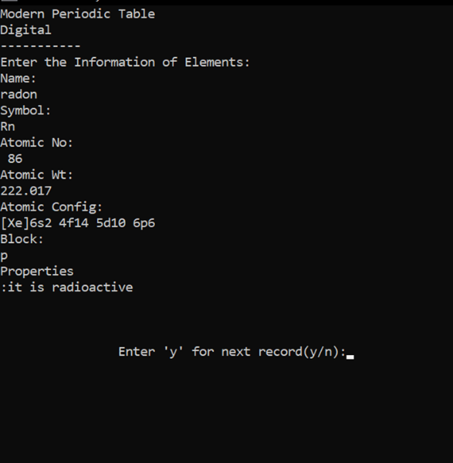 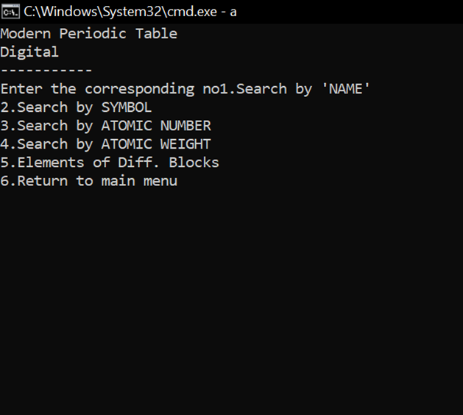

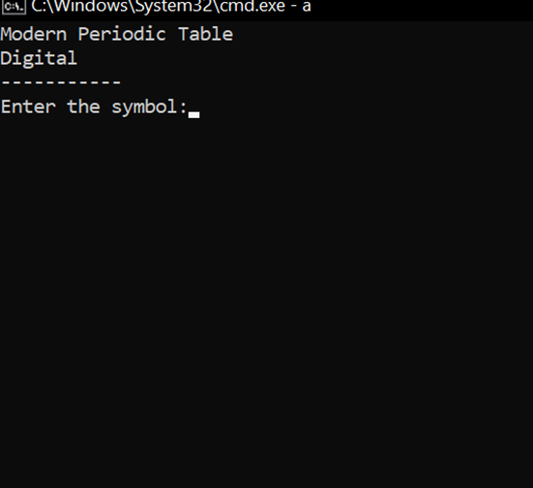 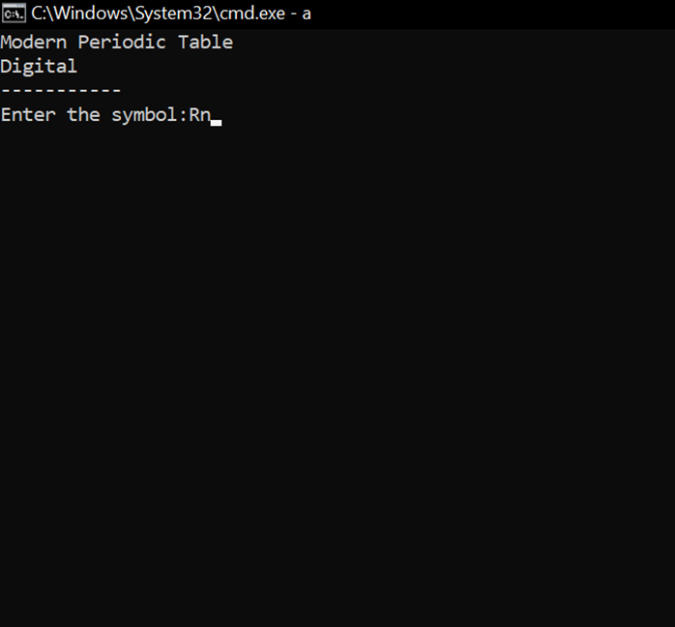

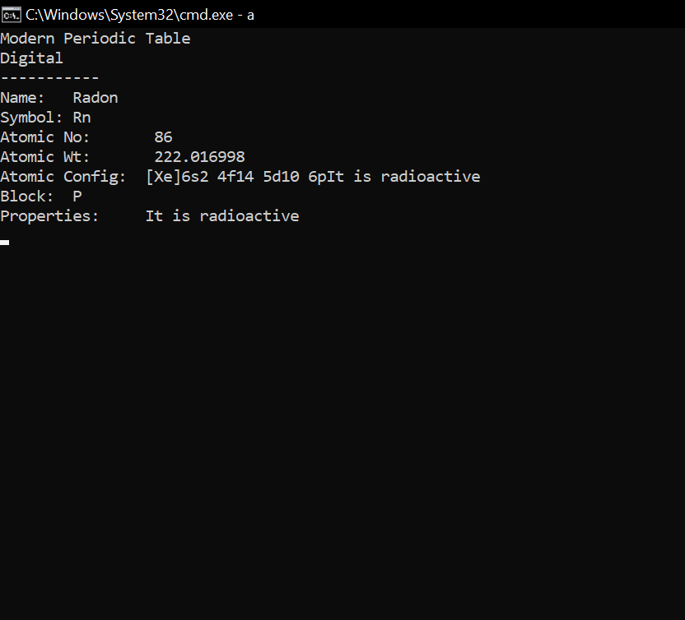

**Name and Signature of the Faculty**

**Kundhavi mam**